A000-US-KY- Rockcastle Co-Effigy- Buffalo-Cherokee-Mudstone-900 CE

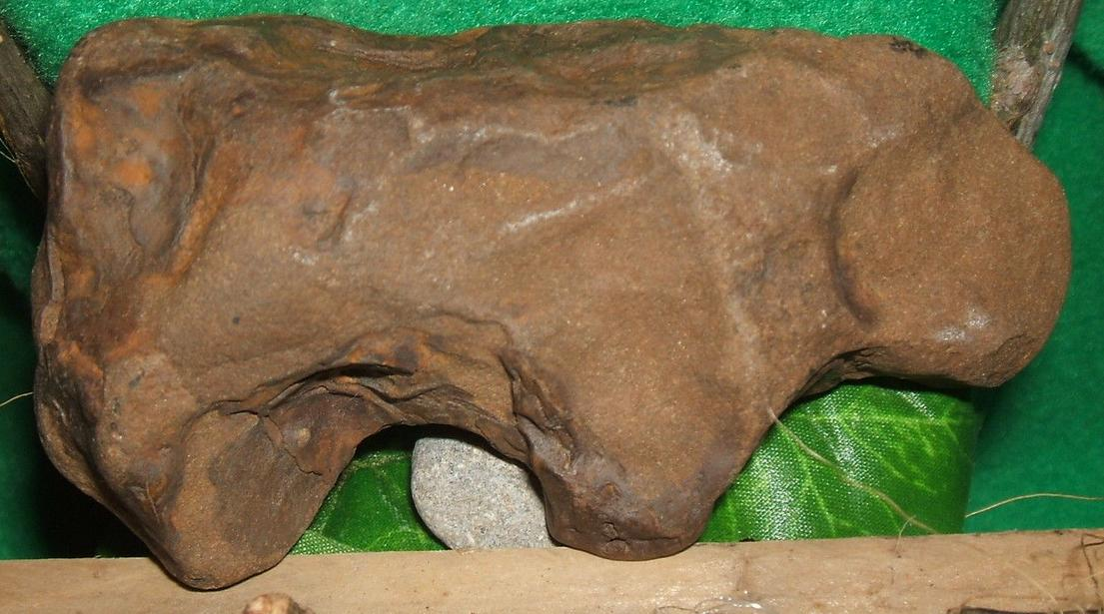

US-KY- Rockcastle Co-Effigy- Buffalo-Cherokee-Mudstone-900 CE

Case No.: 12

**Accession No.**

**Formal Label:** A000- US-KY- Rockcastle Co-Effigy- Buffalo-Cherokee-Mudstone-900 CE

**Display Description:**

buffalo standing, so amazing was the artistic ability of ancient Native Americans,

**LC Classification:**

**Date or Time Horizon:**

**Geographical Area:**

**Map:**

**GPS coordinates:**

**Cultural Affiliation:**

**Medium: mudstone**

**Dimensions: T** 4" W2 1/8 H 1"

**Weight:**

**Condition:**

**Provenance:** Rockcastle Co., Ky. in 2010, my own private property in South Eastern Kentucky

**Discussion:**

**References:**